**NAND LED Circuit**

**Date:** 20/9/2018

**Aim:** To light up the LED in the circuit using a 7400 Quad 2-input NAND, 8-Way switches and to get used to using the inputs and outputs of a circuit.

**Analysis:** Truth Table of NAND gate

We hooked it up as shown in the diagram provided in the lab session.

As there were NAND gates in the 7400 chip we expected the truth table below

|  |  |  |
| --- | --- | --- |
| A | B | Out |
| 0 | 0 | 1 |
| 0 | 1 | 1 |
| 1 | 0 | 1 |
| 1 | 1 | 0 |

**Logic Diagram:**

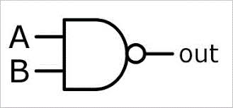

**Results:** Truth Table of our results

From our lab session we got the following results which matched that of the NAND gate truth table which told us that our results were correct

|  |  |  |
| --- | --- | --- |
| A | B | Out |
| 0 | 0 | 1 |
| 0 | 1 | 1 |
| 1 | 0 | 1 |
| 1 | 1 | 0 |

**Conclusion:**

-The truth tables matched that of a NAND gate which is what we expected from the lab project

(bread board) (wires) (7400 chip) (2 high resistors and 1 low) (led bulb) (power supply) (8-way switches)